ANKITA ANAND

850058506

TEST 2 (21-02-2022)

Ans 4)

package com.org.gen.test2;

import java.util.Scanner;

public class Main {

public static void main(String[] args) {

Scanner sc = new Scanner(System.in);

String a = sc.next();

int d = 0;

if (a.length() >= 8) {

if (a.contains("#") || a.contains("@") || a.contains("_")) {

char c = a.charAt(0);

//System.out.println(c);

if (Character.isAlphabetic(c)) {

char dd = a.charAt(a.length() - 1);

if ((Character.isAlphabetic(dd)) || (Character.isDigit(dd)))

{

if (a.matches(".[0-9]{1,}.")

|| a.matches(".[a-zA-Z]{1,}.")) {

System.out.println("Valid");

} else{

System.out.println("Not Valid");

}

} else{

System.out.println("Not Valid");

}

}

else{

System.out.println("Not Valid");

}

} else{

System.out.println("Not Valid");

}

} else{

System.out.println("Not Valid");

}

}

}

Output:

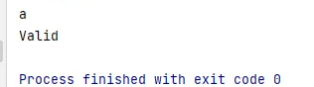

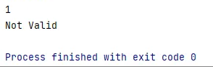

Ans 3)

package org.gen.com.test2;

public class Ncr_Class {

static int nCr(int n, int r)

{

return fact(n) / (fact(r) *

fact(n - r));

}

// Returns factorial of n

static int fact(int n)

{

int res = 1;

for (int i = 2; i <= n; i++)

res = res * i;

return res;

}

// Driver code

public static void main(String[] args)

{

int n = 5, r = 3;

System.out.println(nCr(n, r));

}

}

Output:

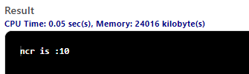

Anss 1)

package org.gen.com.test2;

import java.util.*;

public class Bill {

public static int meterReading(String input1, String input2, int input3) {

int n1 = Integer.parseInt(input1.substring(5, input1.length()));

int n2 = Integer.parseInt(input2.substring(5, input2.length()));

int n = Math.abs((n2 - n1) * input3);

return n;

}

public static void main(String[] args) {

Scanner sc = new Scanner(System.in);

String s1 = sc.nextLine();

String s2 = sc.nextLine();

int n = sc.nextInt();

int n1 = meterReading(s1, s2, n);

System.out.println(n1);

}

}

Output:

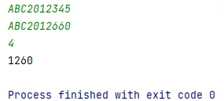

Ans 2)

package org.gen.com.test2;

import java.util.Scanner;

public class ColorCode {

public static void main(String[] args) {

Scanner s = new Scanner(System.in);

String s1 = s.next();

boolean b = colorCodeValidation(s1);

if (b == true)

System.out.println("Valid");

else

System.out.println("Invalid");

}

public static boolean colorCodeValidation(String s1) {

boolean b = false, b1 = false;

String s2 = s1.substring(1, s1.length());

if (s1.length() == 7)

if (s1.charAt(0) == '#')

b1 = true;

if (b1 == true)

for (int i = 0; i < s2.length(); i++) {

char c = s2.charAt(i);

if (c != '#') {

if (s2.matches("[A-Fa-f0-9]{6}|[A-Fa-f0-9]{3}"))

b = true;

else {

b = false;

break;

}

}

}

return b;

}

}

Output:

